Understanding OneDrive - Windows
OneDrive is how we ensure your files are backed up and accessible to you from the cloud. You can access your saved files from any device in which you are logged into OneDrive.

Your local Desktop, Documents, and Pictures folders on your laptop are automatically backed up to OneDrive. OneDrive has to be launched and you need to be logged in for the folders to automatically backup and sync.

To check if OneDrive is launched and you are logged in to it, check the bottom right of your task bar to see if the Blue cloud OneDrive icon is there (In red). You may need to open the hidden icons folder (In green) to check for the icon if it does not appear directly on the taskbar.
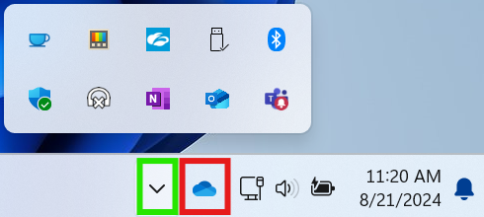

If the blue cloud icon does not appear in your taskbar or the hidden icons folder, you will need to launch the OneDrive app. Simply press the windows button and type OneDrive, then click on the OneDrive app to launch it.
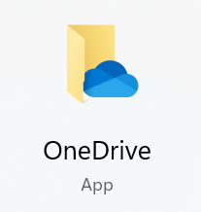

When launched, OneDrive opens a file explorer window. In file explorer, your OneDrive folder is indicated by the cloud icon followed by your name and "- New Balance Athletics, Inc".
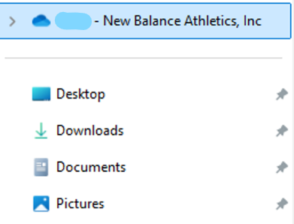

To view your OneDrive activity center, click on the cloud icon in your taskbar. From here you will be able to see what files have been backed up and when, where they have been synced to, and if there are any issues with certain files.
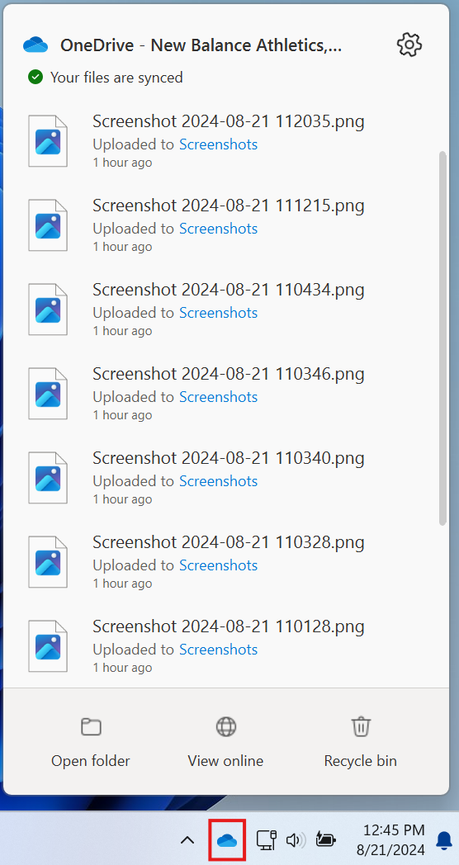

Common OneDrive status icons that you may see:


A gray OneDrive cloud Icon with a line through it means you're not signed in, or OneDrive setup hasn’t completed. Click the icon or launch the OneDrive app to log in.


Circular arrows over the OneDrive icon means that a sync is in progress.


The pause symbol over the OneDrive icon means that your files are not currently syncing. Click the icon, select more and then click Resume Syncing to resume the sync.

A yellow triangle with an exclamation mark means your account needs attention. Click the icon to see the warning message displayed in the activity center.


A red circle with a white X means that a file or folder cannot be synced. Click the icon to learn more about the problem in the activity center.

